I B. Tech. II Semester Supplementary Examinations – October, 2023
Engineering Mechanics
Time: 150 Min (MECH, R&A) Max. Marks: 80M

SECTION – A
Answer all Four questions 4×10M=40M

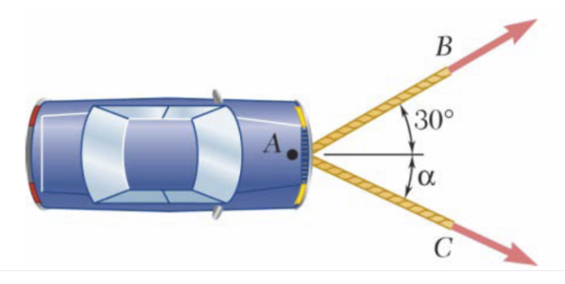
- If the resultant force acting on the disabled car is 30.2 kN in the rightward direction and tension on the AB rope is 20 kN as shown in Fig.1, find the tension on the AC rope connected with the car at A and its direction α with the resultant.

Fig. 1

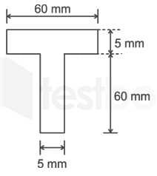
- A T-beam section, shown in Fig. 2, is designed to enhance the rigidity of the beam. Locate the centroid of the section. Also determine the moment of inertia of the section about horizontal centroidal axis.

Fig. 2

- A cable is attached to a 20 kg block A, is looped over a fixed peg at C, and is attached to plate B of 25 kg as shown in figure. If the coefficients of friction, μ_{A} = 0.4, μ_{B}= 0.2 and μ_{C}= 0.0, estimate the inclination of the plane for which motion will impend.
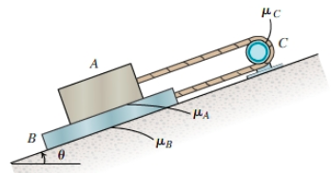
Fig. 3

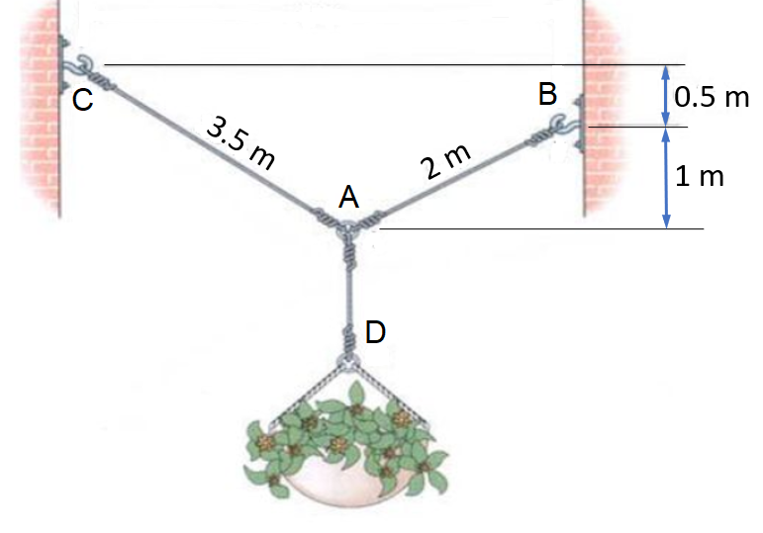
- A flowerpot of 110 N is suspended from three wires and supported by the hooks at B and C as shown in Fig. 4. Determine the tension in the wires AB and AC.

Fig. 4

SECTION - B
Answer all Two questions 2×20M=40M
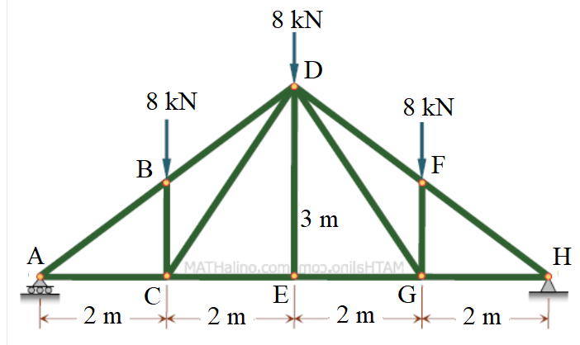
- A Pratt roof truss in a production plant is loaded as shown in Fig. 5.

- Check whether the truss is perfect or not? If not, name the type.
- Find the reaction forces at supports of the truss.
- Estimate the force on the members BD, CD and CE of the truss. Fig. 5
- State the methodology to find the forces on members DF and FG.

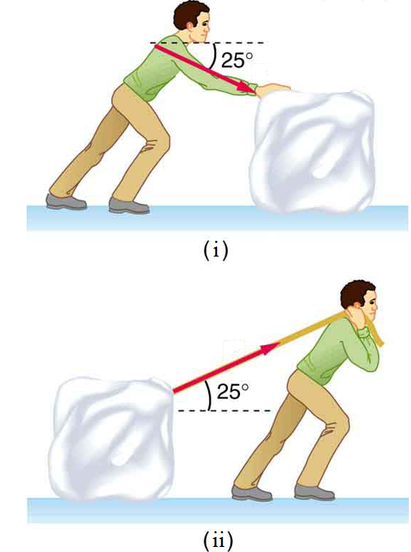
- In a winter sports event, a contestant pushes a 38 kg block of ice across a frozen lake as shown in Fig. 6 (i).

- With a diagram, show what are the forces acting on the block.
- Considering the coefficient of friction as 0.3, determine the minimum force needed to move the block.
- How the friction force on the legs of the contestant can be calculated?
- Instead of push, if the contestant pulls the ice block as shown in Fig. 6 (ii), force required will be more or less as compared to (i)? Justify your answer.

Fig. 6

